**RSG project**

**BIlling report - project ID -q-gcp-6508-rsg-docai-22-01**

**Time duration :-- From Jan 20 to Feb 1st**

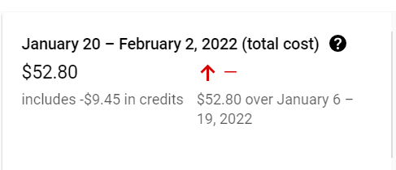

**Services wise cost**

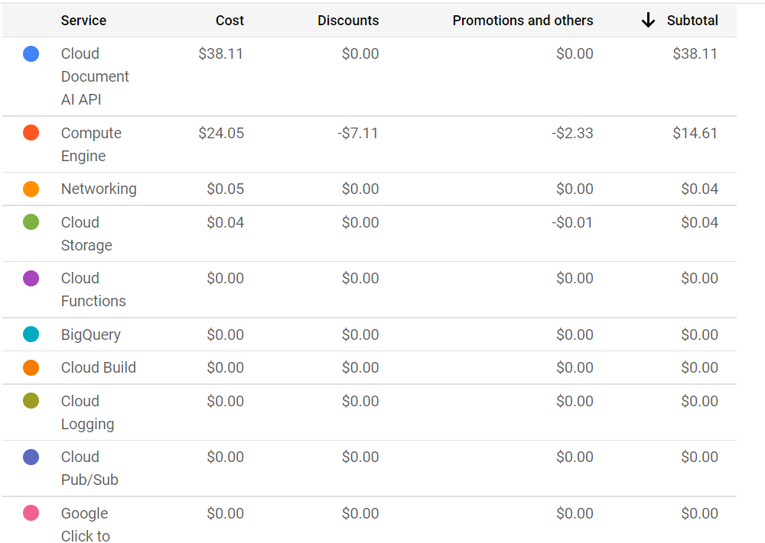

|  | | **Date** | **Per Day Cost** | **Top services -consumed** | | --- | --- | --- | |  |  |  | |  |  |  | |  |  |  | |
| --- | --- | --- | --- | --- | --- | --- | --- | --- | --- | --- | --- | --- | --- |